**Project Design Phase-II**

**Technology Stack (Architecture & Stack)**

|  |  |
| --- | --- |
| Date | 27 June 2025 |
| Team ID | LTVIP2025TMID43995 |
| Project Name | Transfer Learning-based Classification of Poultry Diseases for Enhanced Health Management |
| Maximum Marks | 4 Marks |

**Technical Architecture:**

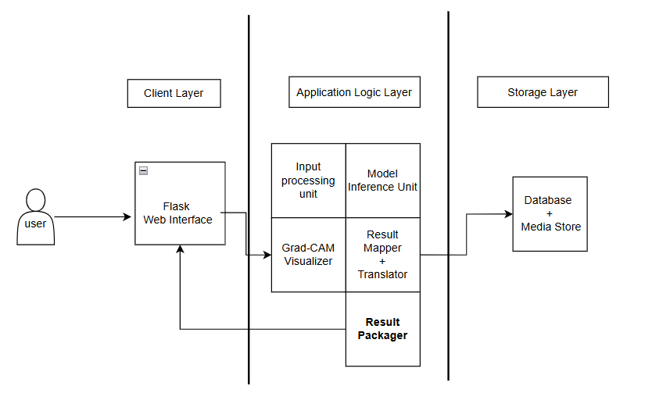

**Table-1 : Components & Technologies:**

|  |  |  |  |
| --- | --- | --- | --- |
| **S.No** | **Component** | **Description** | **Technology** |
|  | User Interface | Web interface for farmers and vets to upload images and input symptoms | HTML, CSS, Bootstrap, JavaScript |
|  | Application Logic-1 | |  | | --- | |  |  |  | | --- | | Backend logic for routing, form handling, and  inference calling | | Python with Flask Framework |
|  | Application Logic-2 | Disease prediction logic using transfer learning | TensorFlow / Keras (ResNet50 / EfficientNetB0) |
|  | Application Logic-3 | Explainable AI output using Grad-CAM | OpenCV, Matplotlib |
|  | Database | Store user info, logs, history, and feedback | SQLite (Local) or MongoDB |
|  | File Storage | Storage of uploaded images and Grad-CAM outputs | Local File System / AWS S3 / Firebase Storage |
|  | External API-1 | For language translation and multilingual support | Google Translate API |
|  | Machine Learning Model | Used for poultry disease classification into 4 categories | Pre-trained CNN + Fine-tuned ResNet50 Model |

**Table-2: Application Characteristics:**

| **S.No** | **Characteristics** | **Description** | **Technology** |
| --- | --- | --- | --- |
|  | Open-Source Frameworks | Web, AI, and Visualization frameworks used | Flask, TensorFlow, Keras, Bootstrap |
|  | Security Implementations | Login/Authentication, HTTPS, input validation, secure data handling | Flask Login, SHA-256, HTTPS (TLS) |
|  | Scalable Architecture | 3-tier structure: UI → Application Server → Model & DB | Flask App with modular MVC separation |
|  | Availability | Can be deployed on cloud or offline; availability depends on hosting medium | Heroku / AWS / Firebase with fallback |
|  | Performance | Optimized ML model, image compression, caching for Grad-CAM outputs, fast REST calls | Model quantization, local cache, Flask |